Use camel case for identifier names , variable names

All names start with a letter.

Always puts spaces around operators and comma (, )

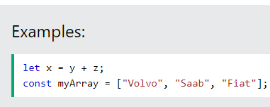

Always put indents(two spaces) into code blocks underneath whenever writing other code

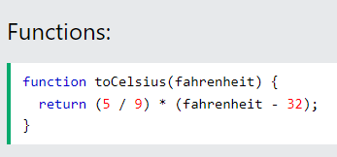



Always ends the simple statement with a semi colon which is a identifier of line complete as well



For complex statement

Object rules

The above code can also be written on the same line :

For readability avoid lines longer than 80 characters. Initialized or used in other sense.

Global variables writtern in uppercase as standard.

For code readability hyphen is often used by programmers

